

Department | FED
Subject | DSA-2
Academic Year | I-III Semester (2025-26)
Faculty Name | Lahari
Student Name | Darahasini.D
Roll Number | 2520030289
Branch | CSE
Course Outcome

CO1
Case Study Topic: Pet Record Management using AVL Trees in PetCare

Work Done Summary:
In this case study, AVL Trees were implemented to manage pet records efficiently in the PetCare platform.
Pet profiles are represented as nodes, and each pet is identified using a unique PetID. AVL Trees automatically maintain balance during insertion and deletion operations, ensuring efficient search and retrieval of pet medical records.
This analysis assists veterinary clinics in maintaining large pet databases while providing fast access to treatment histories, vaccination records, and medical information.
Implementation Details:
- Represented pet records as AVL Tree nodes.
- Used Pet ID as the primary indexing key.
- Implemented AVL Tree insertion operations.
- Maintained balance factors for all nodes.
- Applied left and right rotations when required.
- Performed efficient pet record searching.
- Supported deletion of outdated pet records.
- Generated sorted pet record listings using tree traversals.
- Maintained balanced database structures.
- Reduced search complexity through AVL balancing.
- Improved medical record retrieval performance.
- Integrated AVL Tree operations into PetCare record management functionality

Result: Screenshots/Output
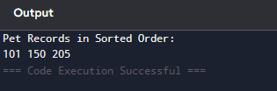

CO2
Case Study Topic: Vaccination Schedule Analysis using B+ Trees in PetCare

Work Done Summary:
In this case study, B+ Trees were implemented to manage and analyze pet vaccination schedules within the PetCare platform.
Vaccination records are indexed using treatment and vaccination dates. B+ Trees support efficient range queries, allowing veterinary clinics to identify pets requiring vaccinations within specific time periods.
This analysis assists clinics in scheduling appointments, generating reminders, and maintaining preventive healthcare programs for pets.
Implementation Details:
- Represented vaccination records within B+ Tree structures.
- Indexed records using vaccination dates.
- Stored keys efficiently across leaf nodes.
- Maintained balanced multi-level indexing.
- Supported range-based vaccination searches.
- Retrieved records between selected date intervals.
- Reduced query processing time.
- Managed large volumes of clinic records efficiently.
- Supported future vaccination reminder generation.
- Improved database scalability.
- Optimized retrieval of preventive healthcare data.
- Integrated B+ Tree indexing into PetCare vaccination management functionality.

Result: Screenshots/Output
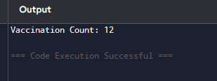

CO3
Case Study Topic: Nearest Veterinary Clinic Analysis using Breadth First Search (BFS) in PetCare

Work Done Summary:
In this case study, Breadth First Search (BFS) was implemented to analyze connectivity between veterinary clinics in the PetCare platform.
Veterinary clinics are represented as nodes, while referral paths and road connections are represented as graph edges. BFS explores neighboring clinics level by level and identifies the nearest reachable veterinary facility from a selected location.
This analysis assists pet owners in locating nearby clinics and helps healthcare providers optimize referral networks and emergency treatment accessibility.
Implementation Details:
- Represented veterinary clinics as graph vertices.
- Represented referral routes as graph edges.
- Created an adjacency list for graph storage.
- Selected a source clinic for traversal.
- Used a queue data structure for BFS execution.
- Visited neighboring clinics level by level.
- Marked visited clinics to prevent repeated traversal.
- Generated clinic accessibility paths.
- Identified nearest reachable veterinary facilities.
- Evaluated referral network connectivity.
- Improved emergency healthcare accessibility analysis.
- Integrated BFS into PetCare clinic network functionality.

Result: Screenshots/Output
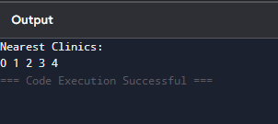

GitHub Link:
Student Signature | Faculty Signature

